PIZZA SALES SQL QUERIES

1. KPI’S
2. Total Revenue:

select SUM(total_price) AS Tatal_Revenue from pizza_sales

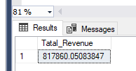

1. Average Order Value

SELECT SUM(total_price) / COUNT(DISTINCT order_id) AS Avg_Order_Value

from pizza_sales

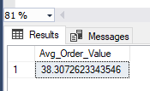

1. Total Pizza Sold

SELECT SUM(quantity) AS Total_Pizza_Sold

from pizza_sales

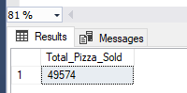

1. Total Orders

SELECT COUNT(DISTINCT order_id) AS Total_Order

from pizza_sales

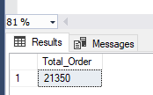

1. Average Pizza Ordered

SELECT CAST(CAST(SUM(quantity) AS DECIMAL (10,2)) /

CAST(COUNT(DISTINCT order_id) AS DECIMAL (10,2)) AS DECIMAL (10,2))

AS Avg_pizza_per_order

from pizza_sales

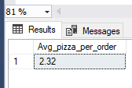

1. CHARTS
2. Daily trend for total order

SELECT DATENAME(DW, order_date) AS order_day,

COUNT(DISTINCT order_id) AS Total_orders

FROM pizza_sales

GROUP BY DATENAME(DW, order_date)

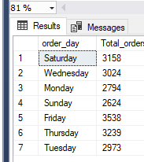

1. Monthly Trend for Total Orders

SELECT DATENAME(MONTH, order_date) AS Month_Name,

COUNT(DISTINCT order_id) AS Total_orders

FROM pizza_sales

GROUP BY DATENAME(MONTH, order_date)

ORDER BY Total_orders DESC

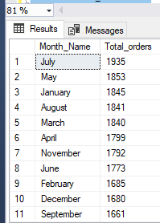

1. Percentage of Sale Per Pizza Category

SELECT pizza_category, sum(total_price) as Total_sales, sum(total_price) *100 /

(SELECT sum(total_price) FROM pizza_sales) AS Per_Revenue

FROM pizza_sales

GROUP BY pizza_category

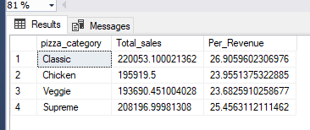

SELECT DATENAME(DW, order_date) AS Order_day, sum(total_price) as Total_sales, sum(total_price) *100 /

(SELECT sum(total_price) FROM pizza_sales) AS Per_Revenue

FROM pizza_sales

WHERE MONTH(order_date) = 2

GROUP BY DATENAME(DW, order_date)

order by Per_Revenue desc

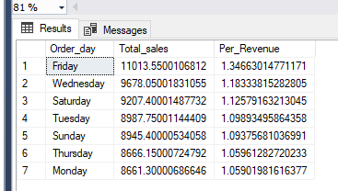

N.B. .MONTH(order_date) = 2 indicates that the output is for the month of Feburary. Also, you,ll get the wrong percentage by not applying the “where” subquery to the first select statement.

SELECT DATENAME(DW, order_date) AS Order_day, sum(total_price) as Total_sales, sum(total_price) *100 /

(SELECT sum(total_price) FROM pizza_sales WHERE MONTH(order_date) = 2) AS Per_Revenue

FROM pizza_sales

WHERE MONTH(order_date) = 2

GROUP BY DATENAME(DW, order_date)

order by Per_Revenue desc

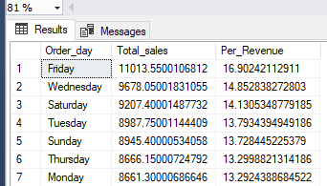

SELECT DATENAME(DW, order_date) AS Order_day, sum(total_price) as Total_sales, sum(total_price) *100 /

(SELECT sum(total_price) FROM pizza_sales WHERE DATEPART(QUARTER, order_date) = 2) AS Per_Revenue

FROM pizza_sales

WHERE DATEPART(QUARTER, order_date) = 2

GROUP BY DATENAME(DW, order_date)

order by Total_sales desc

N.B. DATEPART(QUARTER, order_date) = 2 indicates that the output is for the second quarter

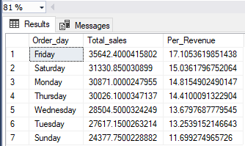

1. Percentage of sales by pizza size

SELECT pizza_size, sum(total_price) as Total_sales, CAST(sum(total_price) *100 /

(SELECT sum(total_price) FROM pizza_sales) AS decimal(10,2)) AS Per_Revenue

FROM pizza_sales

GROUP BY pizza_size

order by Per_Revenue desc

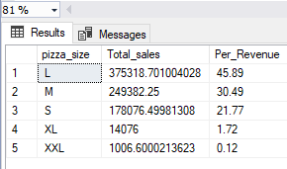

N.B. DATEPART(QUARTER, order_date) = 2 indicates that the output is for the second quarter

SELECT pizza_size, CAST(sum(total_price) AS decimal(10,2)) as Total_sales, CAST(sum(total_price) *100 /

(SELECT sum(total_price) FROM pizza_sales WHERE DATEPART(QUARTER, order_date) =2) AS decimal(10,2)) AS Per_Revenue

FROM pizza_sales

WHERE DATEPART(QUARTER, order_date) =2

GROUP BY pizza_size

order by Per_Revenue desc

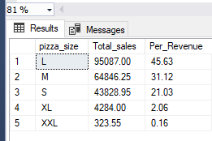

1. Top 5 best sellers by revenue

SELECT TOP 5 pizza_name, sum(total_price) AS Total_Revenue

FROM pizza_sales

GROUP BY pizza_name

ORDER BY Total_Revenue ASC

1. Top 5 least sellers by revenue

SELECT TOP 5 pizza_name, sum(total_price) AS Total_Revenue

FROM pizza_sales

GROUP BY pizza_name

ORDER BY Total_Revenue ASC

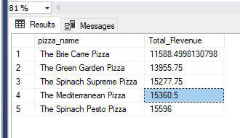

1. Top 5 best sellers by quantity

SELECT TOP 5 pizza_name, sum(quantity) AS Total_Quantity

FROM pizza_sales

GROUP BY pizza_name

ORDER BY Total_Quantity DESC

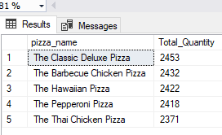

1. Top 5 least sellers by quantity

SELECT TOP 5 pizza_name, sum(quantity) AS Total_Quantity

FROM pizza_sales

GROUP BY pizza_name

ORDER BY Total_Quantity ASC

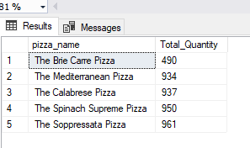

1. Top 5 best sellers by Total order

SELECT TOP 5 pizza_name, COUNT(DISTINCT order_id) AS Total_Order

FROM pizza_sales

GROUP BY pizza_name

ORDER BY Total_Quantity DESC

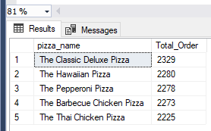

1. Top 5 least sellers by Total order

SELECT TOP 5 pizza_name, COUNT(DISTINCT order_id) AS Total_Order

FROM pizza_sales

GROUP BY pizza_name

ORDER BY Total_Order ASC

